**

**Mathematics Specialist Unit 1**

# Test 3

**Geometry**

|  |
| --- |
| **Name: ______________________ Total Marks:__________** |
|  |
|  |

**Task type: Response**

**Time allowed for this task:** 55 minutes, in-class, under test conditions

Section One: Calculator-free 20 minutes (20 marks)

Section Two: Calculator-assumed 35 minutes (32 marks)

**Materials required:** Calculator with CAS capability (to be provided by the student)

**Standard items:** Pens (blue/black preferred), pencils (including coloured), sharpener, correction fluid/tape, eraser, ruler, highlighters

**Special items:**  Drawing instruments, templates, notes on one unfolded sheet of   
A4 paper, and up to three calculators approved for use in the WACE examinations

Formula sheet

**Marks available: 52 marks**

**Task weighting: 6%**

**Section One : Calculator Free Marks 20**

**Time Allowed 20 minutes**

**Question 1**

[5 marks]

Consider the statement

“If a quadrilateral is a square, then it has 4 equal angles”

1. Write the inverse statement.
2. Write the converse statement.
3. Write the contrapositive statement.
4. Which of these statements are false? Give a counter example

**Question 2**

Determine whether or not $A⇔B$

[2 marks]

A: The two triangles are congruent.

B: The two triangles have corresponding angles equal.

**Question 3**

(3 marks)

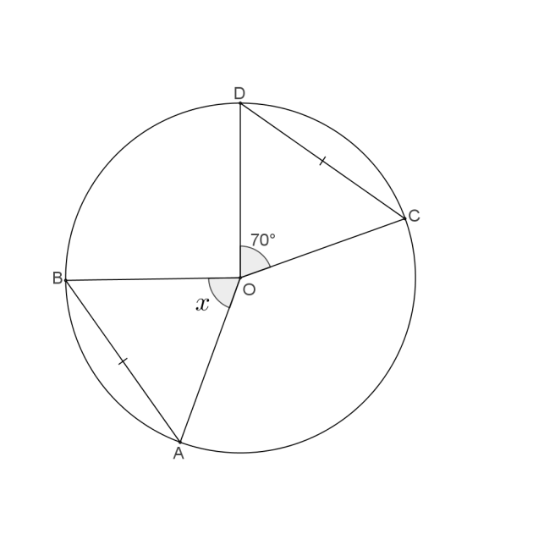Find the value of $x$, showing appropriate reasoning.

**Question 4**

(5 marks)

OABC is a trapezium with $\vec{OA}=a$, $\vec{AB}=b$ and $\vec{OC}=2\vec{AB}$



Prove that the midpoints of the sides form a parallelogram.

**Question 5**

[5 marks]

Using the method of proof by contradiction. Prove that if $3n+2$ is odd then $n$ is odd.

**Section Two : Calculator Assumed Mark 32**

**Time Allowed 35 minutes Name:_______________________**

**Question 6**

[5 marks]

1. 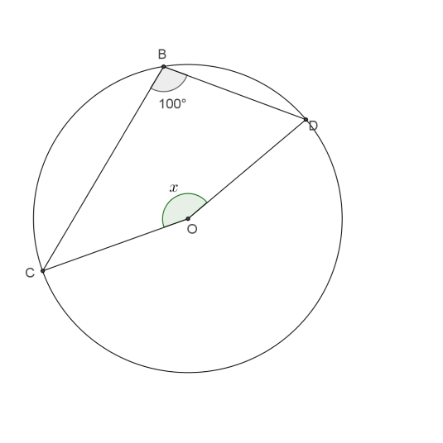Find the value of $x$, showing appropriate reasoning.
2. 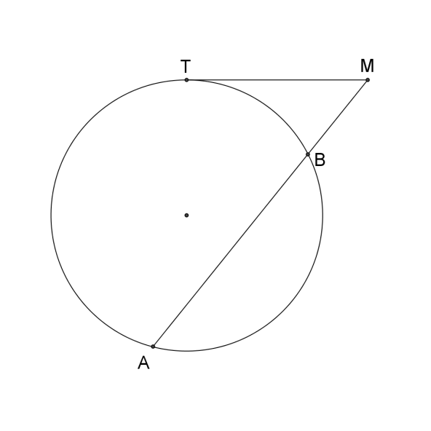Given that TM=6m and BM=4m. Find AB

**Question 7**

[5 marks]

In the diagram below EA and EC are tangents to the curve

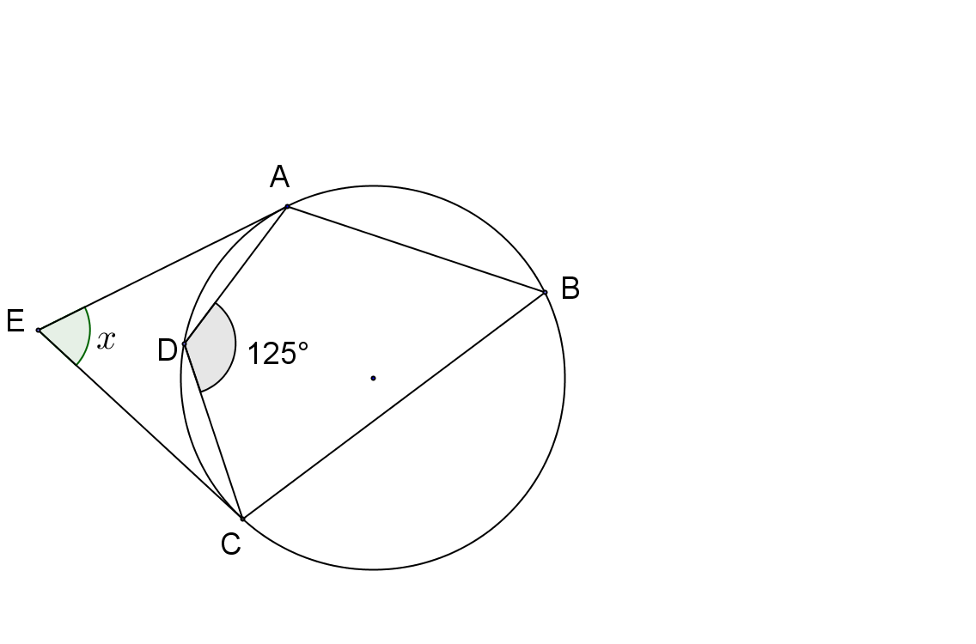 $∠AEC=x° .$ Prove that $x=70$

**Question 8**

(3 marks)

Two line segments are drawn as tangents from an exterior point P to a circle with centre C as shown.

Prove that these segments are congruent.



**Question 10**

[5 marks]

Prove that CE is the diameter of the circle.

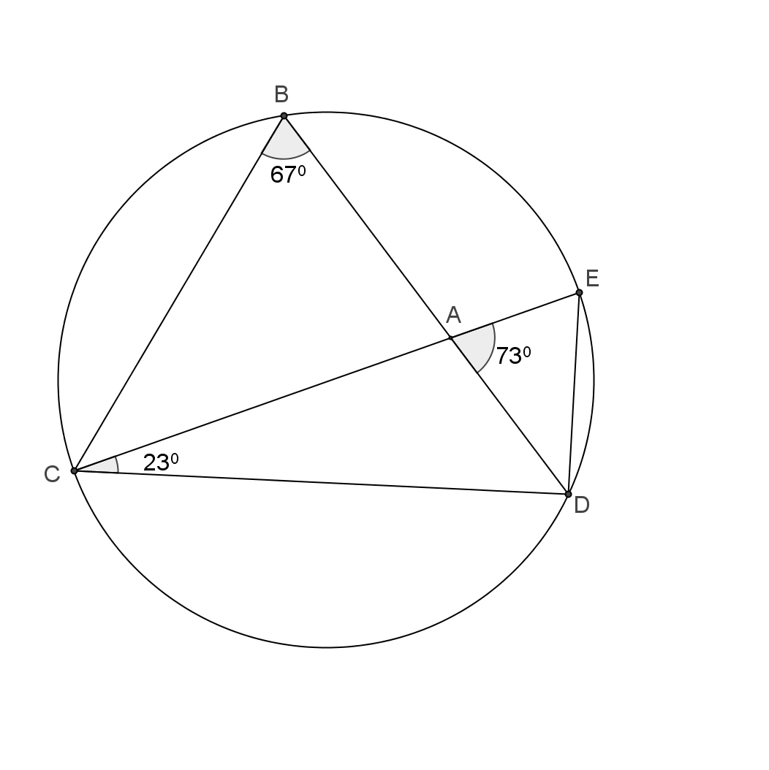

**Question 11**

[6 marks]

1. Two circles with the same radius and centres and intersect as shown. The length of the common chord joining the points of intersection is 20 cm. Determine the exact radius of the circles.



1. In the circle shown below with centre *O* and radius 30cm, the lengths AC and BD are equal, as are the lengths AB and BC . Determine the length OB.



**Question 12**

[8 marks]

1. Prove that $AB×AD=AC×AE$

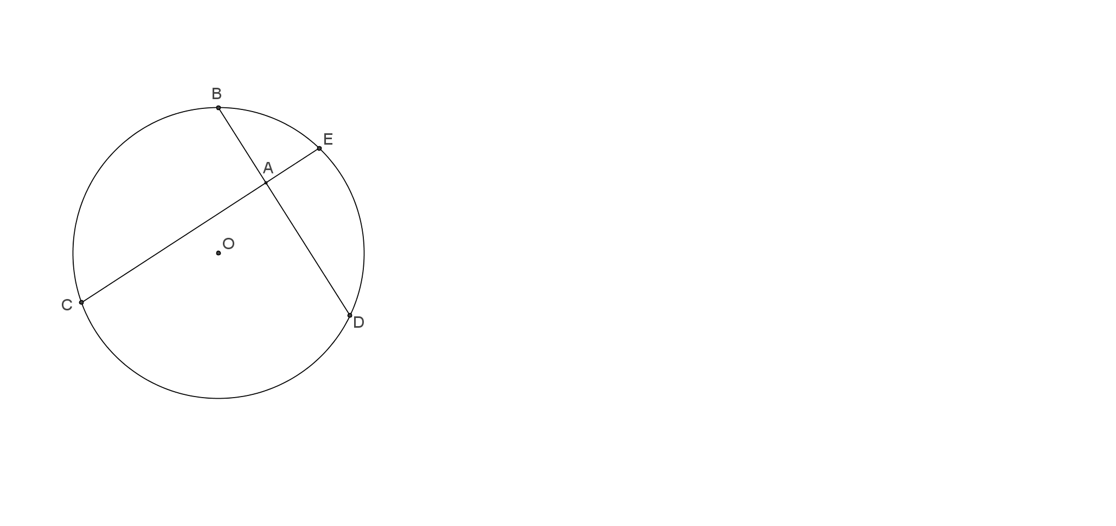

1. Given that AB=4cm, AD=6cm and 2AE=AD. Find the ED.